Tests fort contains currency
- Screen shot of terminal output of tests
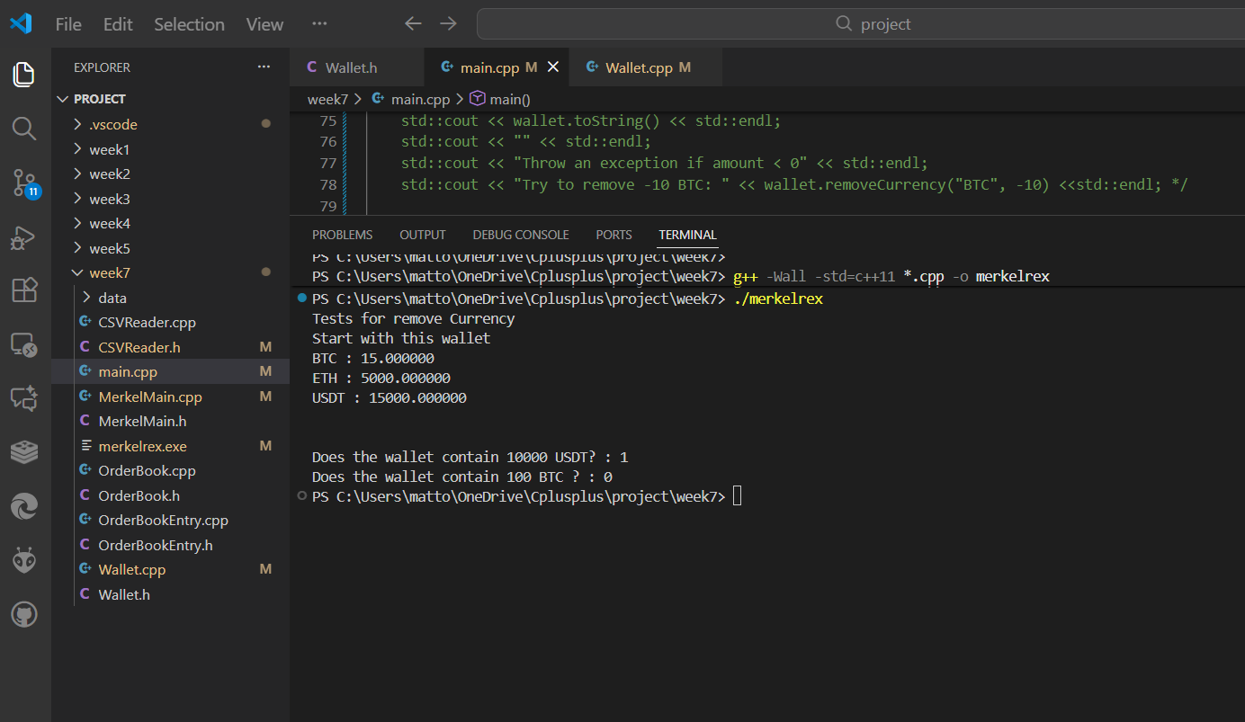
- Test script in main() function
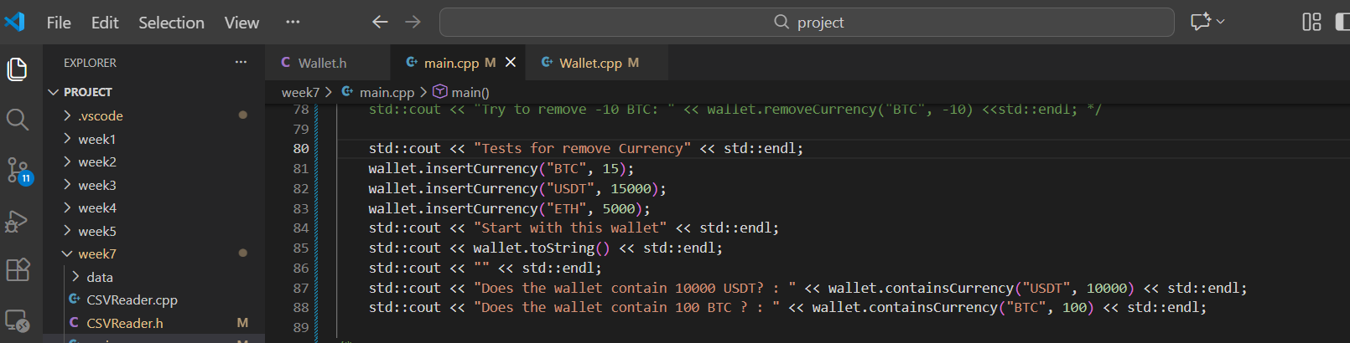
- Screen shot of containsCurrency() function from Wallet class
